FOR IMMEDIATE RELEASE: August 13th, 2009
Contact: Viera Levitt, 401.714.9698, http://vieralevitt.org/mobileartproject.htm, vieralevitt@gmail.com
Hera Gallery, Islay Taylor, PO Box 336, Wakefield, RI 02880, 401.789.1488, info@heragallery.org

Mobile Art Project

Announces the Locations for its First Show

Aqua Alta
August 13th – August 18th, 2009

Hera Gallery in collaboration with Independent Curator, Viera Levitt, is pleased to announce the launch of the Mobile Art Project. This project presents contemporary artwork within the space of a 16-foot box truck. The first project in the truck is a sound installation by internationally exhibiting artist, China Blue, entitled Aqua Alta.
Tentative schedule
Please note that these locations are subject to change. For updated information about time and locations, please check http://vieralevitt.org/mobileartproject.htm or call 401.714.9698
Date | Before noon | Afternoon or evening
Thursday  August 13th | Peace Dale Village rotary
Friday  August 14th | TBA | West Kingstown Train Station 3pm – 5pm  Parking lot of the Courthouse Center for the Arts from 6.30pm to 8pm, before their performance Fame: The Musical
Saturday  August 15th | FOO Fest, Empire Street, AS220, Providence - 1pm - 5.30pm
Sunday  August 16th | "The Wall", Ocean Rd, Narragansett | Peace Dale Village Green from 5pm (before the concert of Avenue A at 6pm)
Monday  August 17th | Parking lot outside of Belmont Market, Wakefield
Tuesday  August 18th | Senior Center, Wakefield  10 am - noon | Peace Dale Library parking lot 1:30 - 4:30pm

Aqua Alta is presented in a 16-foot box truck, which travels to various locations in South County (Peace Dale, Wakefield, West Kingstown, Narragansett) as well as to Providence. Visitors are able to stand or sit on benches inside the truck and listen to sounds from the sea especially collected and presented for this occasion. By creating this meditative environment in a public space, we hope to bring a different experience to our visitors, who are very used to the sights of the ocean and rivers, living as we do in the ‘Ocean State’. Our goal is to provide a space to contemplate and think about the water that surrounds us, but whose sounds often go unnoticed. Additionally, the Mobile Art Project is collaborating with Save The Bay, which enables to discuss the ecological aspects of the project.
Artist China Blue recorded sound for ‘Aqua Alta’ with specialized audio equipment including hydrophone arrays and seismic microphones. The work captures the unique sounds of the water and the creatures of Providence's canals and Narragansett Bay. Sounds are sampled from the water’s edge, and around and under the gondolas in the lagoons. This work was inspired by the effects of global warming on the environment, both under and above the surface of the water.
According to the artist, her installation Aqua Alta, “echoes the ebb and flow of water on our planet. The same water that washes the canals of Venice, breaks at the feet of the Statue of Liberty and runs through the canals of Providence. It rises up and rains down. It is as ordinary as it is threatening.”
The Mobile Art Project:
The intention of the Mobile Art Project is to bring contemporary art to communities in Southern Rhode Island where few or no formal art institutions currently exist. Providing art that ‘travels’ to local shopping districts and recreational sites our goal is to bring art to a general population rather than having people travel to exhibitions. The Mobile Art Project also wants to make contemporary art not only physically accessible but psychologically accessible as well. By showcasing art that doesn’t necessarily need a formal art education to appreciate we want to remove the stigma that contemporary art is too complicated to enjoy.
We invite the public to propose future sites where they feel that Mobile Art Project’s presence would be valuable.

Independent curator Viera Levitt (www.vieralevitt.org) often takes art out from the ‘artificial bubble’ of traditional exhibition spaces and into a wide array of public spaces including moving trains, train stations and urban environments where the public and the work can interact. She has curated or co-curated more than forty exhibitions in Slovakia, the Czech Republic, Germany, Austria, Luxembourg, and the USA.
China Blue (http://chinablueart.com) is an internationally exhibiting artist who pursues the intersection of sound, art and architecture. Her work has been shown in museums, galleries and non-profit spaces around the world. She is represented by Galerie Barnoud, Dijon, France and Art Currents, New York.
Hera Gallery (www.heragallery.org), founded in 1974 as a site for woman’s art, understands the need to provide art that engages the unengaged and that makes art physically and aesthetically accessible. The Hera Educational Foundation promotes an artistic presence that enhances the community through education, collaboration and involvement and encourages artists and their audience to explore contemporary cultural, social and aesthetic issues.
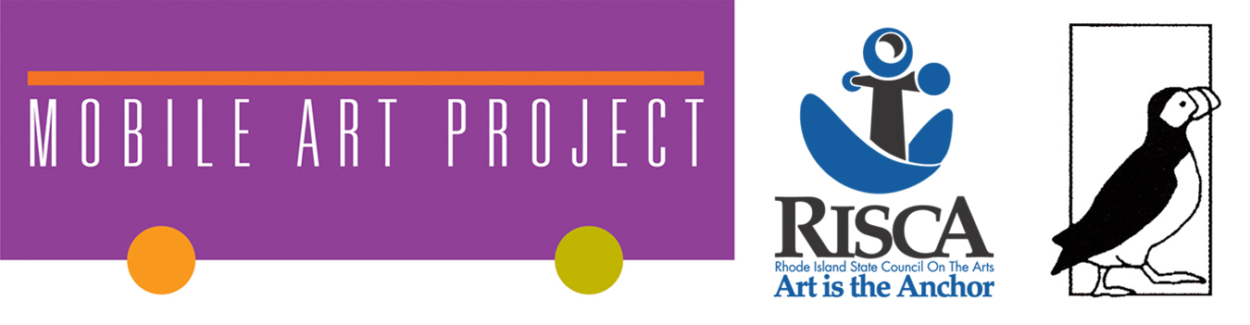
This program is presented with partial support from The Rhode Island State Council on the Arts, The Puffin Foundation, Hera Educational Foundation, and The Friends of Hera.
Hera Gallery is free and open to the public and is accessible to persons with disabilities.
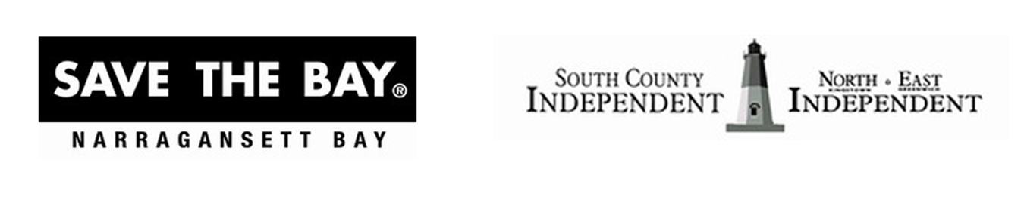
Partner of the project: Save the Bay
Media partner: Independent Newspapers
Special thanks:
Belmont Market, Judith Tolnick Champa, Rachel Calabro, Jeannette Jacobs, Guy LaTour, Jim Smart, Liberty Rentals, South County Tourism Council, South Kingstown Parks and Recreation Department, Peace Dale Neighborhood Association; Penske, Cranston Headquarters and others

#####

